YOU’RE INVITED ON A CLACKAMAS RIVER WATERSHED TOUR
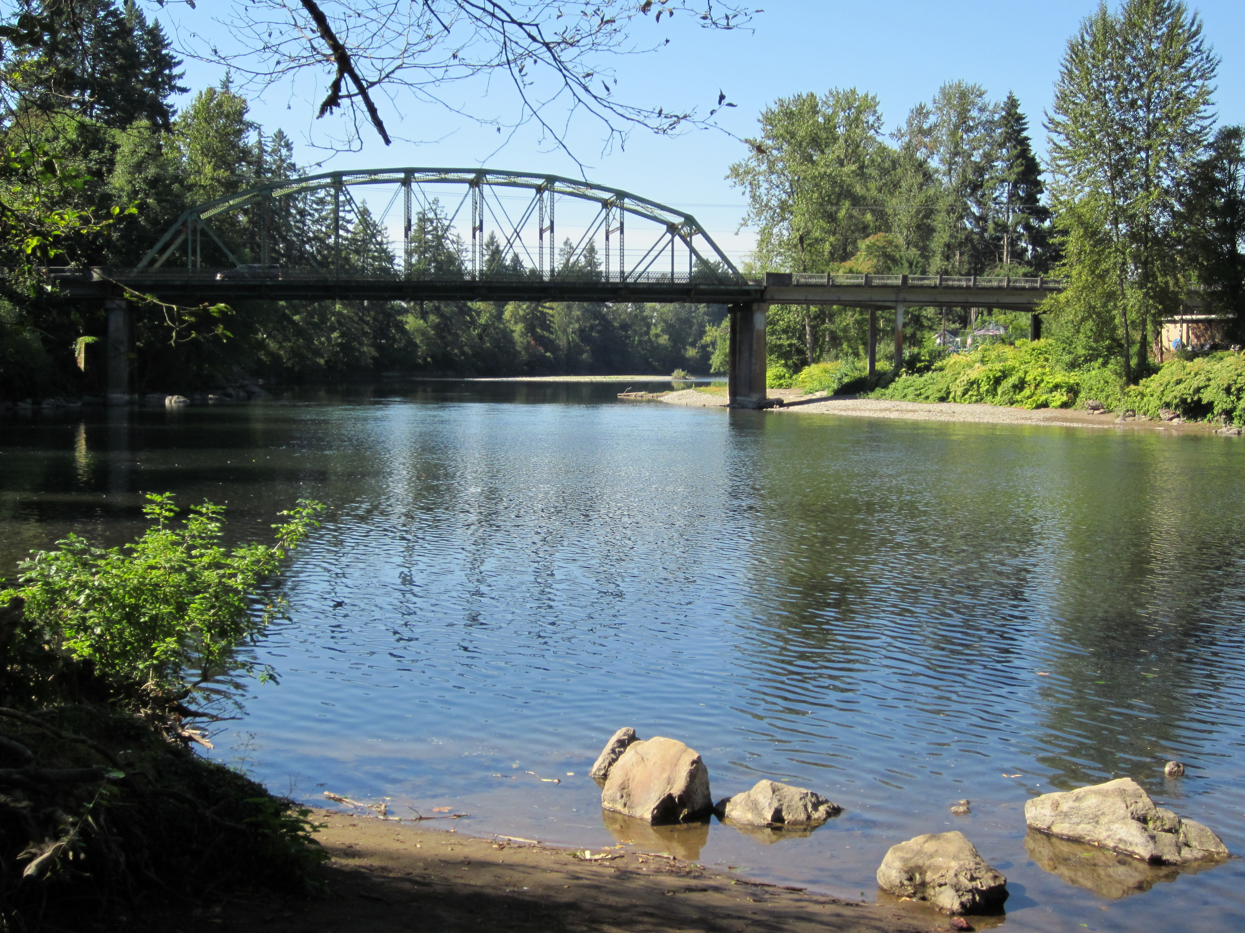

Please join the Clackamas River Water Providers (CRWP) for an informative and engaging tour of the lower Clackamas River watershed.

This year our tour will include stops at all four CRWP member water treatment plants in the lower river. Combined these plants provide water to over 300,000 people in Clackamas and Washington Counties. Participants will learn how each plant works, how they are different, how all our systems are interconnected, as well as some of the future challenges we face as water providers.

Date: Saturday, October 5th, 2024
Time: 8:00 a.m. to 3:00 p.m.

All transportation, meals, snacks and beverages will be provided by the Clackamas River Water Providers. The day will begin with a light breakfast of coffee, juice and pastries at Clackamas River Water’s water treatment plant located at 9100 SE Mangan Drive Clackamas, OR 97015.

Lunch will be served at the North Clackamas County Water Commission water treatment plant and plenty of snacks and beverages will be provided on the bus. Please dress appropriately for fall weather conditions and wear sturdy shoes for exploring points of interest.

Please RSVP by September 25th
to Christine Hollenbeck, Clackamas River Water Providers
Public Outreach & Conservation Coordinator at christine@clackamasproviders.org

Space is limited on this tour and seats can fill up fast. Call early to reserve a space.
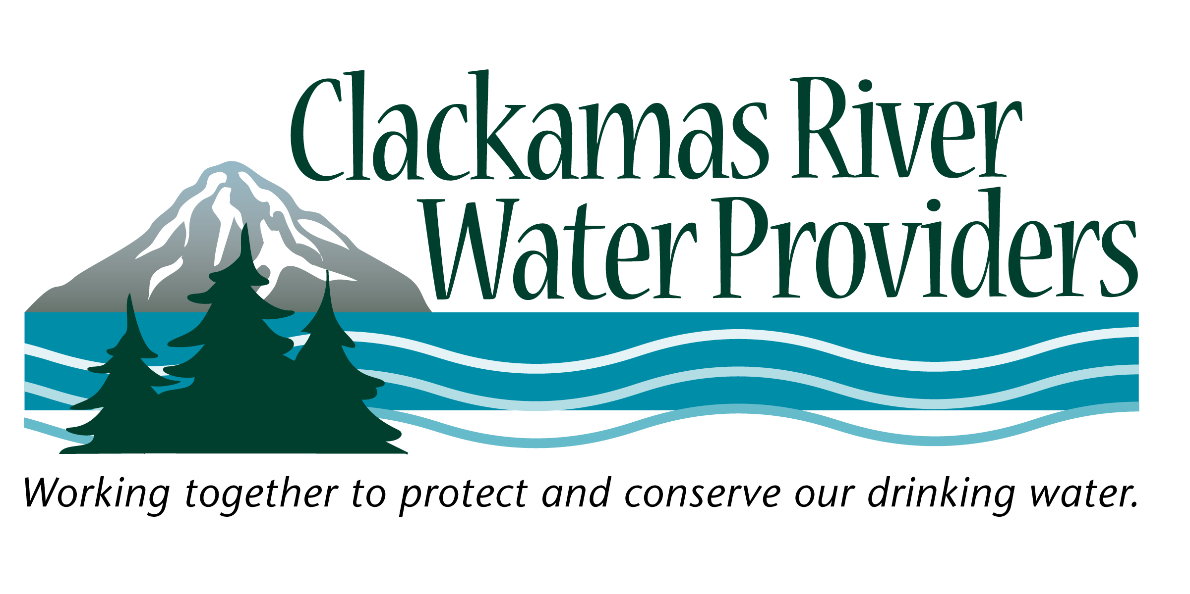

Serving
Clackamas River Water, City of Estacada, City of Lake Oswego, City of Tigard, The North Clackamas County Water Commission (Oak Lodge Water Services and City of Gladstone), South Fork Water Board (City of Oregon City and City of West Linn), and Sunrise Water Authority (Happy Valley and Damascus)

